Wellington North Open 2024

Fri 29th – Sun 31th March 2024
Wellington North Badminton Stadium
Taylor Park
Tawa, Wellington 5028

Tournament Organiser  Wellington North Badminton  www.wnba.org.nz |  | Sanctioned by  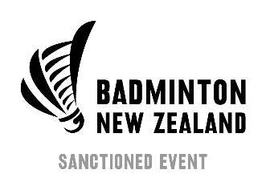
A Badminton New Zealand sanctioned event (Group B1)

Entries can only be made via ONLINE ENTRY at
Badminton New Zealand – www.badminton.org.nz
Wellington North Badminton – www.wnba.org.nz
Early Bird Entries!! Ends 11.59, Wednesday 13th March 2024
Entries close 11.59pm Wednesday, 20th March 2024
Late entries or entries without payment will not be accepted.

Tournament Director
Chanmony Khieng
chanmony@wnba.org.nz
+644 232 4774

PROUD SUPPORTERS

Tournament Accommodation
Thanks to our accommodation partner Willis Wellington Hotel, please take advantage of the special rate on offer:
- Only $150.00-$180.00 per night
- Use promo code: WNBA2024
- Breakfast included
- Cancellation- 48 hours Cancellation policy applies
- Room Type- Standard Twin, Queen, or Triple
- FREE transfer between hotel and stadium
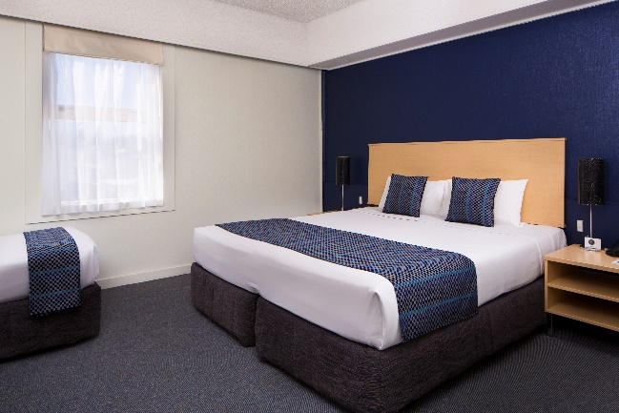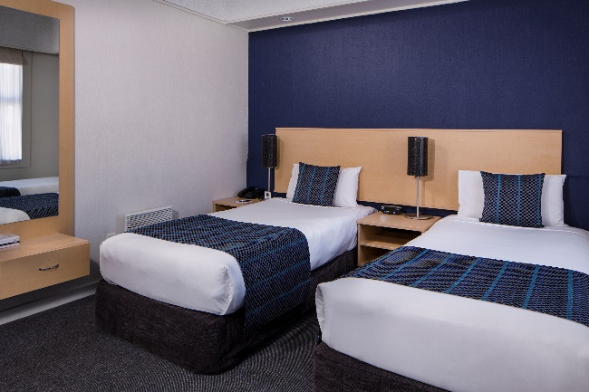
Willis Wellington Hotel is located centrally on Willis Street in the funky, cosmopolitan Cuba Quarter, the Willis Wellington Hotel is just a short walk from the CBD and is in the heart of Wellington’s cool café culture.

*** First in First Serve, Rooms on hold for our Open ***
- 2 x twin studio @$175 for 2, $195 for 3 people
- 3 x two bedroom unit @$270 for 4, $290 for 5 people.
- 3 x standard studio @$175
- 1 x one bedroom unit @$185 for 2, $205 for 3 and $225 for 4 people.

CONDITIONS OF ENTRY
Please read and take special note of entry and fee payment requirements.

RULES AND REGULATIONS
  - It is expected that players will have read and are familiar with the ‘Conditions of Entry’ prior to submitting an entry.
  - Any player entering must be a member of an association affiliated with Badminton New Zealand or the Badminton World Federation. All players must be in good standing with their member association and Badminton New Zealand.
  - Only players born in 2009 or earlier can participate in this tournament.
  - The rules of play shall be the BWF Competition Regulations and Laws of Badminton.
  - The BWF scoring system is to be used. Best of 3 games to 21 with extension if required.
  - All questions as to the rules shall be resolved by the tournament Referee.
  - Feathered shuttles will be used.
  - The tournament organiser and/or Referee reserve the right to:
    - Cancel any event in which fewer than 8 entries are received, or if time does not permit a full competition to be played.
    - Change the scoring of plate events if time constraints require.
  - Default a player who is not available to play at the scheduled time.
  - This event will be played using the Alternative Service Law 9.1.6. The whole of the shuttle shall be below the server’s waist at the instant of being hit by the server’s racket. The waist shall be considered an imaginary line around the body, level with the lowest part of the server’s bottom rib, and the shaft and racket head of the server’s racket at the instant of hitting the shuttle shall be pointing in a downward direction.

SEEDINGS, DRAW AND SCHEDULE
  - The tournament will be seeded as per the Badminton New Zealand National Rankings in the Seniors category at the close of entries.
  - The draw will be made on Monday, 25 March 2024 and will be available on the Wellington North Badminton website by 5pm Monday, 25 March 2024.
  - The first day’s schedule will be available by 5pm Wednesday, 27 March 2024 on the above website.
  - Matches may be called 10 minutes earlier than the scheduled time.
  - Schedules of play are as following:
Friday 29 March, from 11am | Up to first 2 rounds of all events
Saturday 30 March, from 9am | All events up to semi-finals including plates
Sunday 31 March, from 9am | All events semi-finals; finals not before 12pm

ENTRY DETAILS
  - Entry can only be made online and must be received no later than 23:59 on Wednesday 20th March 2024. Online entry can be made through www.wnba.org.nz and/or www.badminton.org.nz
  - Entries for doubles and mixed doubles will not be accepted unless full payment is received from both partners by the closing time/date. This excludes ‘partner required’ entries. It is not the responsibility of the tournament organiser to follow up on entries from nominated un-entered partners.
  - Players may withdraw from individual events without being required to withdraw from all events.
  - Players withdrawing after entries have closed will not be eligible for a refund unless a medical certificate is submitted at the time of withdrawal.
  - There will be no refunds for players withdrawing after the draw has been published.
  - There will be no substitution in the singles events.
  - Substitution is only allowed in the doubles events from players already entered the tournament and must be approved by the Referee.
  - Only one Player in each Pair in the draw can be substituted.
  - If two Players from two different pairs in the same Event are put together, the placement of the new pair shall be at the position of the pair seeded in the highest seeding group. If none of the pairs is seeded, or seeded in the same seeding group, the position shall be drawn by lot between the positions of the two original pairs.
  - A $20 administration fee will be deducted from all refunds.
  - A compulsory BNZ player levy of $16.00 is payable by all players (built into all entry fees).
  - Plates may be played in all events: Men’s Singles, Women’s Singles, Men’s Doubles, Women’s Doubles, and Mixed Doubles. Plate entry is automatic for losers of their first match played. Players wishing to withdraw must advise the Referee immediately after their first match loss. If a player defaults, withdraws or retires (does not complete) their first match they are not eligible for the plate events.
  - Plate events are not eligible for Player Points.

ENTRY FEE
  - The entry fee for all players is $86 (inclusive of the $16 BNZ Player Levy) – for all early bird entries. All other entries from Thursday 14th March until entry closing is $116.00 (inclusive of the $16 BNZ Player Levy).
  - Players can choose to play up to three events.
  - All entries must be paid (via PayPal) as part of your online entry.

Prizes
  - $2,000 prize money is offered, subject to Wellington North Badminton receiving a minimum of 60 unique player entries in the tournament. There will be medals for winners and runners-up for all main draw events, and winners for plate events. Prizegiving will be completed after all finals have been completed, with the prize money being paid in cash.
  - Semi-finalists will only be awarded prize money if there is a minimum of 16 entries (pairs for doubles) in the event. This will be provided at the conclusion of the semi-finals.
  - Wellington North Badminton reserves the right to redistribute or reduce the price money accordingly.
 | MS | WS | MD* | WD* | XD*
Winner | $200 | $200 | $250 | $250 | $250
Runner-up | $75 | $75 | $100 | $100 | $100
Semi-finalists | $25 | $25 | $50 | $50 | $50
*Per pair

PLAYER REQUIREMENTS
  - Players must ensure that the tournament organizer is advised if they wish to leave the playing venue. Players who have lost matches may be required to umpire even after they have finished their events.
  - Matches may be called up to 10 minutes prior to the scheduled time, players must be ready to play when called to the court.
  - Players must wear regulation badminton clothing as per the Badminton New Zealand Approved Clothing regulations. Further details can be found here: Clothing Code - Badminton New Zealand
  - On Player clothing the Player’s name, if used, shall be identical to the name registered as the Last Name in the Badminton NZ database, and if desired, the initial(s) of the name(s) registered as the First Name in the Badminton NZ Player Database. Last Name is defined as the family name, surname, or similar name under the naming protocol of New Zealand.
  - All players must act as umpires or line judges when requested. Failure to do so may result in the player being defaulted. Please check the websites prior to the session for player umpires (if needed).
  - Players compete at their own risk. No responsibility will be accepted for any injury received during this tournament.
  - By entering this event, the player hereby agrees and acknowledges that any person, shall have the right to photograph and/or record on video all and any games or practice conducted during the course of the event, retain such photographs or video recordings for their own use of whatsoever nature, distribute such photographs or video recordings to any other party, display such photographs or video recordings during the event or any time thereafter, in any form whatsoever (including, but not limited to: promotional displays of the organisers and/or the sponsors of the event or any similar event, social network sites, the website(s) of the organisers and/or sponsors of the event and of Badminton New Zealand) PROVIDED THAT no such photographs or video recordings shall be used or retained for any illegal, immoral or unseemly use or purpose.

Covid-19
  - Wellington North Badminton Association will be following the COVID-19 requirements as advised by the New Zealand Government, Ministry of Health, and Sport New Zealand throughout this tournament. Such requirements may include, however, not limited to face coverings, personal hygiene, etc.
  - Wellington North Badminton Association reserves the right to suspend, postpone or cancel the tournament in line with these requirements.
  - If a player returns a positive test result for COVID-19; is awaiting a test result; deemed a household contact or self-isolation at the start of the tournament, this player needs to advise the tournament organiser and shall be withdrawn from the tournament. The player shall be entitled to a refund of entry fees (minus the admin fee as stated in clause 3.8.), and their partners shall receive a refund for the affected events if a suitable substitute is not available.
  - We will provide players with a full refund of their entry fee if the tournament is suspended or cancelled, however, will not consider financial reimbursement of any other costs related to the tournament.
  - If the event is postponed Wellington North Badminton Association will automatically transfer each participants entry and entry fee to the new date. If a player wants to withdraw their entry, they may do so following standard withdrawal processes online before the new closing date.
  - We reserve the rights to disqualify any player from the tournament who are deemed to have disregarded any reasonable instruction related to the Wellington North Badminton Association’s COVID-19 response. This includes, but is not limited to wearing of masks, contact tracing and social distancing. Further guidance can be found under News and Updates on our website:
www.wnba.org.nz

